Guidelines
- Parent/carers will always be welcomed in school as partners in the learning process.

- Concerns and issues will be dealt with in a professional, friendly, sensitive and prompt manner.

- Parent/Carers will be encouraged to build supportive relationships with class teachers by telephoning the school, writing, a note, having a brief word at the beginning of the day or if more time is necessary, by making appointments at mutually convenient times.

- Important information from the school will be sent to Parent/Carers via the fortnightly newsletter or a specific letter.

- Where a child has an individual need, parents/carers will be contacted and invited into school to help resolve it.

- Parents/ Carers will be given regular feedback on their child’s learning, progress and achievement through two parents’ evenings during the Autumn and spring term and a written report in the Summer Term.

- Parent/Carers will be encouraged to be involved in the life and work of the school in many ways including:

- Working in classrooms with children or in support of teachers

- Helping with extra – curricular activities and school visits

- Being involved in social and fundraising activities
Outcome
Parent Involvement
Policy

The ethos of Easterside Academy will be one in which Parents/Carers and staff are mutually supportive. As a result, our children will benefit in their development, progress and achievement. This partnership will give our children the best opportunity to benefit from school. Our links with Parents/Carers and the community will be used to help further develop and promote community cohesion.

Overview
At Easterside Academy we aim to encourage teachers and Parents/Carers to support each other in the education of our children. We welcome the involvement of Parent/Carers in the work and life of the school. Knowing that this ensures children thrive and do well.
This policy outlines how we aim to develop and maintain an effective and positive working relationship between school and home for the benefit of the child.
We are working towards the Leading Parent Partnership Award which will recognise and improve the ways we work with Parents and Carers.
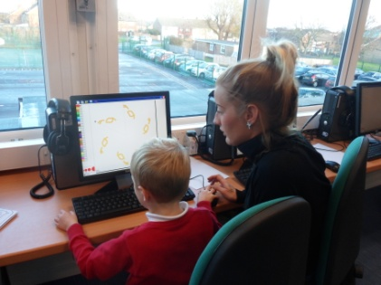

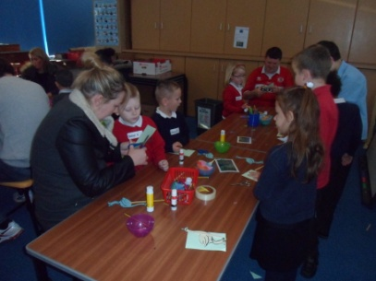

Aim
- To involve Parents/Carers as partners in the work and life of the school helping us to promote the school’s aims and policies.

- To create simple and user friendly communication systems with Parents/Carers to keep both school and home informed of what is happening in their child’s life.

- To gather and put into action Parent/Carer views and ideas where possible.

- Enhance every child’s learning opportunities by using the skills and experiences available from both the Parent/Carers and local community.

- To involve Parents/Carers in the social and extra curricular life.
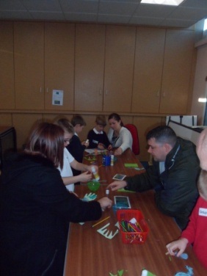

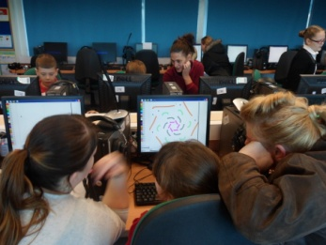

Objectives

- Actively involve Parents/Carers in the education and progress of their child by:

- Sharing with Parents/Carers a clear and accurate picture of their child’s progress and achievement.

- Working with Parents/Carers in identifying learning goals for children and in finding and implementing agreed solutions when problems arise.

- Involving Parents/Carers in meeting learners’ individual and special needs.

- Building on the work that Parents/Carers have done with their children and enabling them to continue to support the learning process both in and out of school.

- Identify the skills and experiences of Parents/Carers and consider how these can be fully utilised to support children’s learning opportunity.

