How can your child achieve a Super Student Award?
Your child needs to:
- attend school every day
- be punctual every day

- wear the school uniform every day

- complete homework when set

- have a consistent positive attitude

- with no time outs or isolations

On a Friday, two pupils from each KS2 class
are awarded Super Student. Those
children are given the opportunity to go
in for their lunch first; that means no
queue and no waiting! They then have
the privilege of dining on our posh
Captain’s table, where they are served their dinner and juice!

The school believes in rewarding good behaviour and promoting positive behaviour.
- All pupils and adults should be able to work in a friendly atmosphere alongside each other, showing respect for differing abilities and needs, so that all children can reach their full potential.
- All pupils are expected to develop a responsibility for themselves and towards others.
- All pupils are expected to care for their school environment.

Praise, rewards and commendations are given, on a regular basis, to promote a good ethos.
- Stamps and comments in books | - House points
- Stickers and certificates  - Head Teacher Award | - Super student awards  - Certificates

Certificates and commendation are celebrated in Friday assemblies.

BEHAVIOUR FOR LEARNING

AIM OF THE SCHOOL

To be a safe, happy, creative and successful school which enhances the life chances of its pupils, and which is an integral part of the life of the local community.

- Treat others as you would like to be treated.
- Listen to adults in school and do as they say.
- Work sensibly, safely and tidily.
- Respect our school and everything in it.
- Think about what you do and about what will happen.
- Try your best to complete your homework.

BEHAVIOUR FOR LEARNING

At Easterside Academy we believe that everyone has a responsibility to ensure that learning has a positive experience for all.

Why?

Because pupils can’t learn if they or others misbehave.

How?

- By encouraging and rewarding positive behaviour.
- By promoting good behaviour and respect for others.
- By developing self esteem, self discipline and a proper regard for authority.
- By providing a clear framework of rules, rewards and sanctions which are consistently applied.
- By nurturing parental and pupil involvement in the achievement of acceptable behaviour.
Anti-Bullying

Bullying can be emotional, physical, homophobic, verbal, racist, cyber or sexual. We respect all children regardless of age, gender, race, sexual orientation, culture or disability. They have a right to be safe and free from bullying in our school.

We aim, as a school, to produce a safe and secure environment where all can learn without anxiety and measures are in place to reduce the likelihood of bullying.
Easterside Academy’s aims:

- Everyone in the school takes responsibility for combating bullying.
- Victims feel protected and supported.
- Those engaged in bullying are encouraged to change their behavior and their attitudes about bullying.
- The bully will offer an apology and other appropriate consequences may
take place.
- If possible the pupils will be reconciled.

Easterside Academy’s Objectives:

- All Governors, teachers, non-teaching staff, parents and pupils have an understanding of what bullying is.
- All Governors and teaching and non-teaching staff will know what the school policy is on bullying and follow it when bullying is reported.
- All pupils and parents should know what the school policy is on bullying and what they should do if bullying arises.
- As a school we take bullying seriously. Pupils and parents should be assured that they will be supported when bullying is reported.
- Bullying is unacceptable and will not be tolerated.

Sanctions
Why sanctions?
The academy aims to provide a calm working environment where teaching and learning can take place effectively.
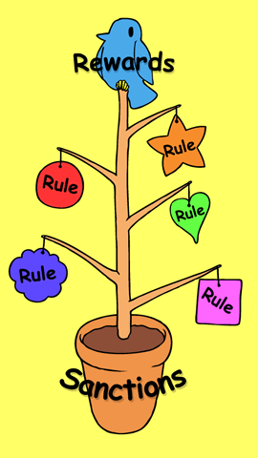
When pupils behave in a disruptive or disrespectful way anywhere around the school, sanctions will be imposed.
What sanctions?
- Verbal warnings

- "time out"

- Isolation

- discussion with parents/ carer

- home/school contracts in partnership with the Local Authority

- involvement of professional agencies

- exclusion, as a last resort

