Easterside Academy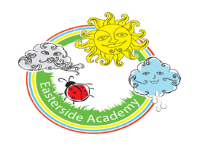
Class 10 HNB - Home Learning - Week beginning: 30.3.20
Hello to all of Class 10! We hope you have had a good first week of home learning. We are going to setting up a Class page on the free app 'SeeSaw' for you to share your fantastic learning with us! A message has been sent on Marvellous Me with a link to join, keyworkers will pass on information of how to join the page when making phone calls this week. At the end of this document there is a QR code to scan within the app to access Class 10’s page.

Activity: | Phonics activity ideas:  - I spy something that starts with…. (initial sounds focus)  Encourage child to identify the first sound in a word. Go on a hunt around the house for items starting with different sounds.  - Practise the alphabet song daily; a great one to sing while washing hands!
Phonics
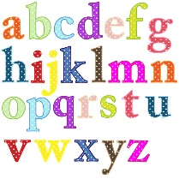

Literacy/Topic | - First name writing daily; if able to write first name independently, encourage to write surname also. Write your name in different ways; with a pencil, in different colours, with water and a paintbrush outside etc.  Spring Focus: look outside the window/ clips on YouTube. What changes can you see? What Spring signs do you notice?  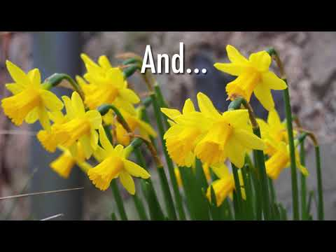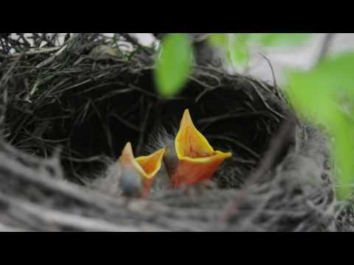  - To draw a spring picture and label it.  - To record the weather each day.  - If you brought a beanstalk home last week, continue to observe changes in it over time!  Other topic activities:  - Make an Easter card  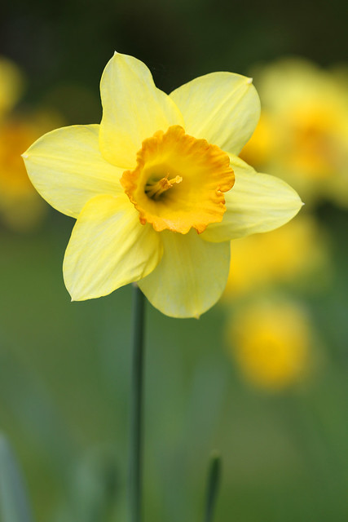  - Go on an Easter egg hunt  - Draw some spring flowers
Stories and Rhymes | This week’s stories and Rhyme: Link to Spring & Easter.  - Read your school reading book with an adult.  Things to think about…  Who is the author? illustrator?  Where is the story set? Who are the character? What happened at the beginning, middle and end?  - Read books at home with an adult.  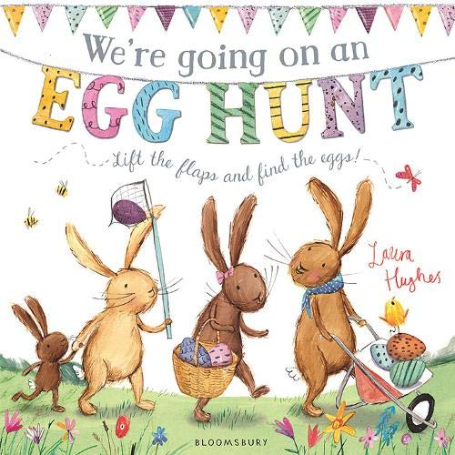Youtube; We're going on an egg hunt
Maths | Maths Learning Focus-  Counting to 20 daily (if confident up to 20, count to higher numbers), counting back from 10 daily  Counting objects around the home- putting them in a line and touching 1:1 as they count- what is one more? Less?  Number formation practise- practise writing numbers 0-10 correctly. Write them in different ways; with a pencil and paper, with paint, with water and a paintbrush, with your finger in salt/sand/flour.  Youtube; Jack Hartmann Count to 100 songs  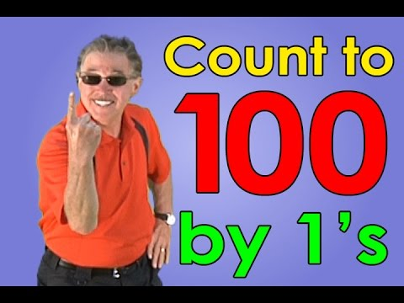
Physical Fun! | YouTube; cosmic yoga  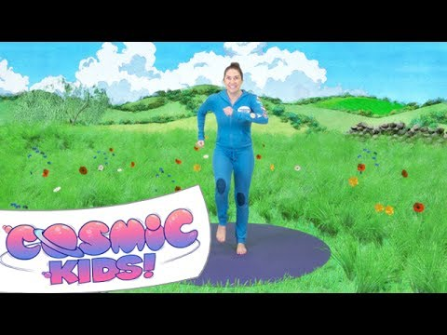  Here is a link to practising some Yoga moves.  How many different ways can you move?  Daily Joe Wicks PE lessons; YouTube 9am  This week’s Challenge: See if you can move in different ways-  Hopping and jumping like a Easter bunny, skipping like a baby lamb…. What else can you think of?
Final Thoughts | When you get to the end of the week have a think about all the things you have learnt.  Is there anything I want to find out about more about?  Is there anything I need to practise again?  Encourage your child to keep revisiting their learning.  Have a lovely week!

Download Seesaw App
Select ‘I’m a Pupil’
Scan this QR code to access Class 10’s page
Post photos and comments to show us what you’ve been learning at home!

