Easter Holiday Activities
Over the next two weeks, feel free to complete any of the activities below if you wish. Please upload any photos: we would love to see them! If you manage to complete 20 or more activities – at least one from each column - and we see evidence of this, you will be entered into our Easter draw. The winner will be drawn and announced on Seesaw on Monday 20th. Good luck!
Maths Related Activities | English Related Activities | Easter Related Activities | Life Skills
Complete Easter related maths activity 1  (see below) | Write a fact file on one of the characters from Pig Heart Boy | Decorate a hard-boiled egg | Learn how to make your own bed
10 minutes on Times Tables Rock Stars | Write a summary for the story of Pig Heart Boy so far | Organise a family egg hunt | Learn how to load the dishwasher or wash, dry and put away
15 minutes on Sumdog | Complete 20 minutes on Reading Plus | Take part in a family egg and spoon race | Learn how to wash your clothes
Complete Easter related maths activity 2  (see below) | Write an ending for Pig Heart Boy | Enjoy a garden picnic | Learn how to fold a jumper or shirt
20 minutes on Times Tables Rock Stars | Write a Newspaper report which reveals Cameron’s secret operation | Plant a spring flower | Learnt how to knit or sew
30 minutes on Sumdog | Complete 30 minutes of Reading Plus | Make an Easter Card for a loved one | Learn how to prepare a simple meal
Complete Easter related maths activity 3  (see below) | Right a formal letter of complaint in the role of an Animal Right’s Activist to Dr Bryce regarding the transplant procedure | Read all about Easter and complete the labelling activity  https://www.bbc.co.uk/bitesize/topics/ztkxpv4/articles/z4t6rj6 | Learn how to cook a simple meal
30 minutes on Times Tables Rock Stars | Pick a character from Pig Heart Boy and write a diary entry linked to any point in the story | Watch ‘The Story of Easter Story: the Beginner’s Bible’  https://www.youtube.com/watch?v=0PSgoPdKQFQ | Learn how to write a shopping list with a budget
40 minutes on Sumdog | Complete 40 minutes on Reading plus | Retell the Easter story in any form you wish (through pictures, a comic strip, a video) | Learn how to dust and polish
Complete Easter related maths activity 4  (see below) | Write a poem linked to bravery, secrets, trust, or friendship | Make Easter nests or hot cross buns | Learn basic first aid
Maths Activity 1 | Maths Activity 2
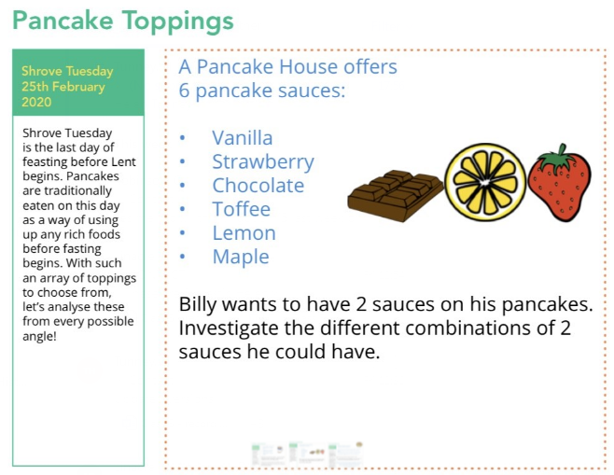  How many different combinations are there? | 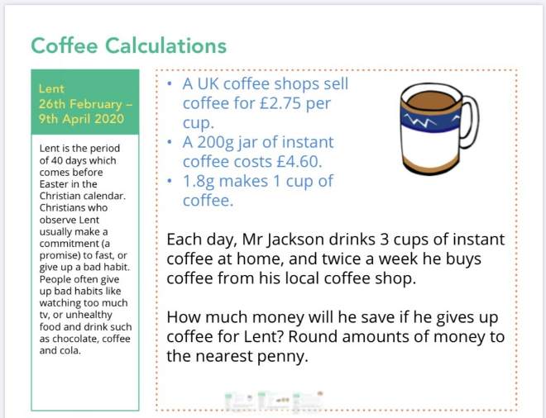
Maths Activity 3 | Maths Activity 4
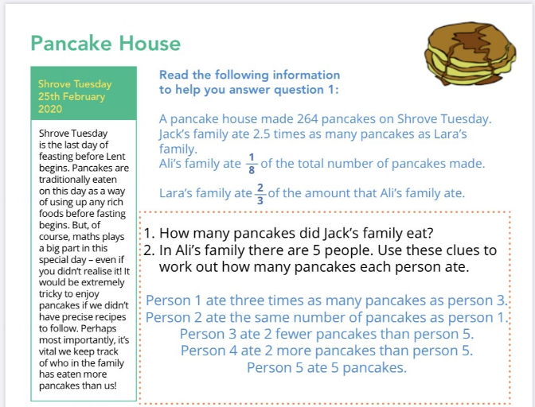 | These are the ingredients needed to make six pancakes:  100g plain flour  2 large eggs  300ml milk  1 tablespoon of oil  Ask each member in your household how many pancakes they each want.  Work out how must of each ingredient you would need to make your full family pancakes.
For more maths activities, you can visit White Rose Hub https://whiterosemaths.com/homelearning/easter-fun/ where there will be two new challenges to complete daily. Every time you complete two of these challenges, they will count as one of your 20.
How many different combinations are there?
How many different combinations are there?

