Easterside Academy 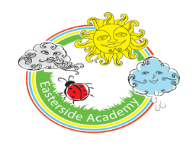
Home Learning-Week beginning: 30.3.20
Activity: | Phonics activity ideas:  Nursery:  - I spy something that starts with…. (initial sounds focus)  - Initial sound sheets https://cleverlearner.com/letter-sounds/beginning-sound-worksheets.html  Reception:  - Word Building (CCVC words and longer words) e.g. slip, ship, shop, chip, chop, crab, grab, press, flock, frock, crust, brisk (use letter packs to build words) Practise writing these words  - Write/read simple sentences: The crab went on the sand/ She had a pink frock and it had spots/ She went to the shop for some chips/The ship was on the pond/ The man can chop a block.
Phonics
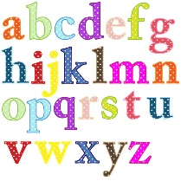

Literacy/Topic | Nursery: First name writing daily (cursive handwriting writing)  Reception: First and Surname (cursive handwriting)  Nursery & Reception:Spring Focus: look outside the window/ clips on YouTube.What changes can you see? What Spring signs do you notice?  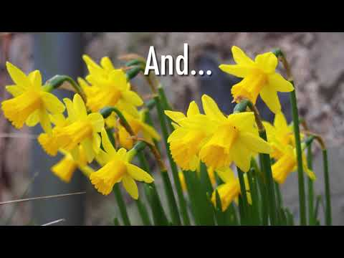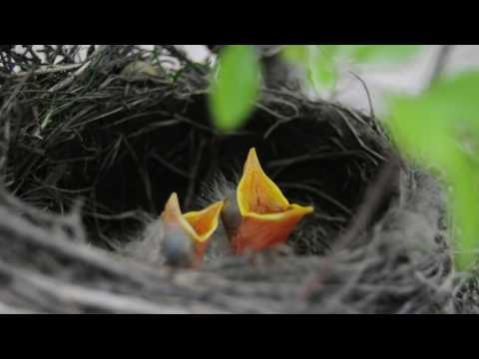  Nursery: 1.To draw a spring picture and label it. 2.To record the weather each day.  Reception: 1.To notice some signs of Spring- write a simple sentence(s)- Focus on fingers spaces/ capital letters and full stops. 2.To record the weather each day  Nursery & Reception: Other topic activities:  - Make an Easter card  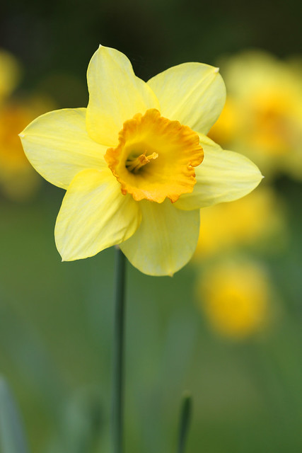  - Go on an Easter egg hunt  - Draw some spring flowers
Stories and Rhymes | This week’s stories and Rhyme: Link to Spring.  As well as reading your own stories and home reading book this week, here are some links to a lovely story and rhyme.  What stories and rhymes have you shared this week?  Things to think about…  Who is the author? illustrator? publisher?  Where is the story set? Who are the character? What happened at the beginning, middle and end?  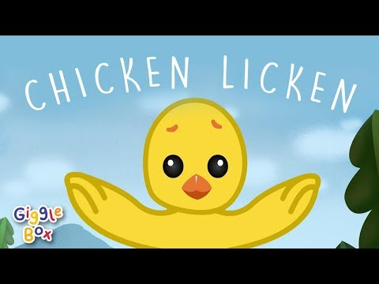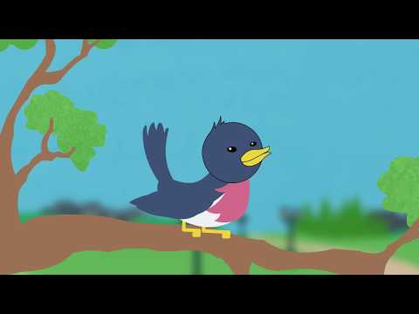
Maths | Maths Learning Focus-  Nursery: Counting aloud to 20 daily, Number songs  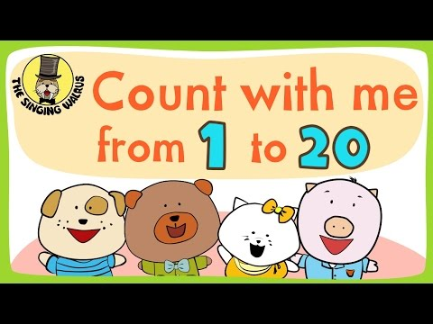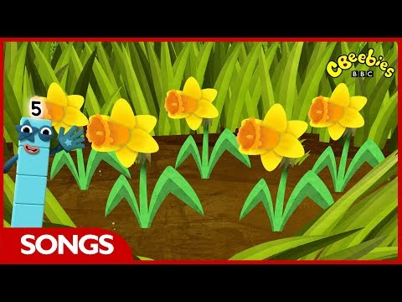  Counting objects around the home- putting them in a line and touching 1:1 as they count- what is one more? Less?  Reception: Counting to 100/ counting in 2s/3D shape song daily  Doubles- use objects to practise double up to 16 (Double 1,2,3,4,5,6,7,8)  Practise writing number sentences for these e.g. 4+4 =8  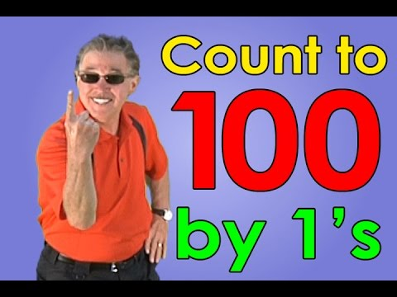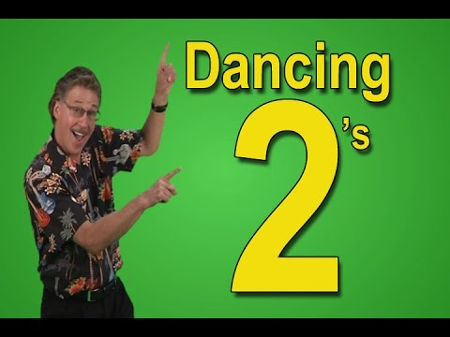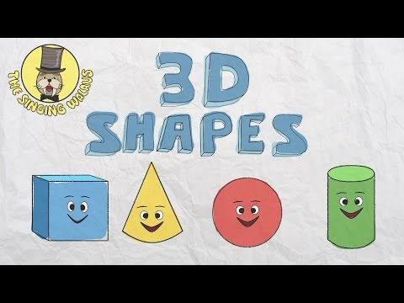
Physical Fun! | 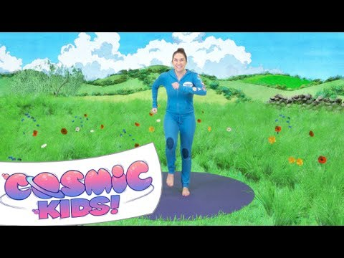  Here is a link to practising some Yoga moves.  How many different ways can you move?  This week’s Challenge: See if you can move in different ways-  Hopping and jumping like a Easter bunny, skipping like a baby lamb…. What else can you think of?
Final Thoughts | When you get to the end of the week have a think about all the things you have learnt.  Is there anything I want to find out about more about?  Is there anything I need to practise again?  Encourage your child to keep revisiting their learning  Have a lovely week!

